**Website Issues**

# Include Field “Place” to Sync with Admin Panel Customer List Column “Place”.

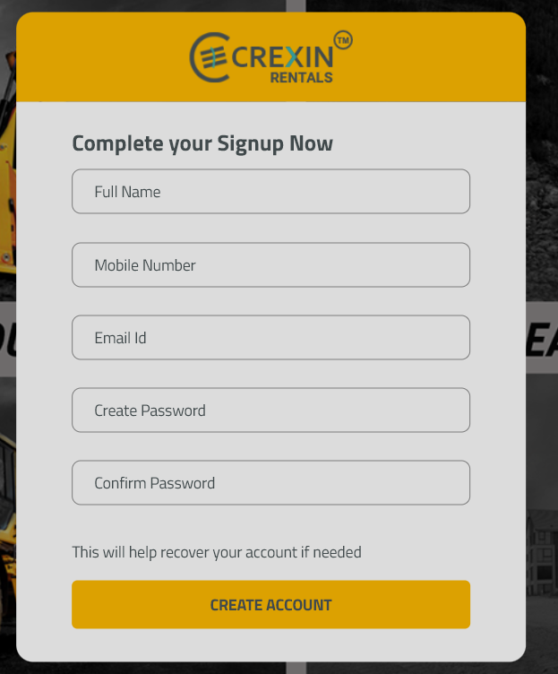

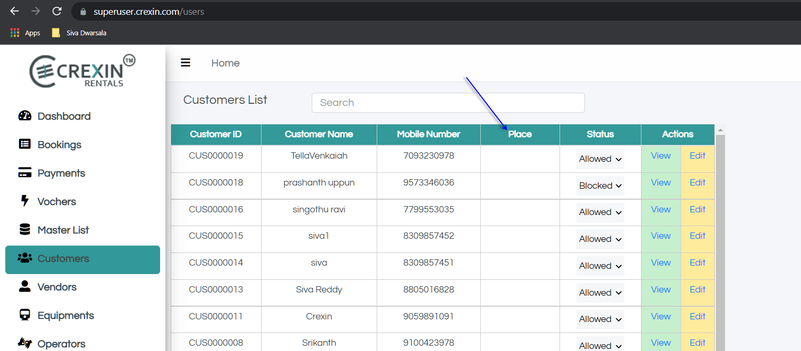

# Booking Summary Tile : Make Booking Summary Tile as below.

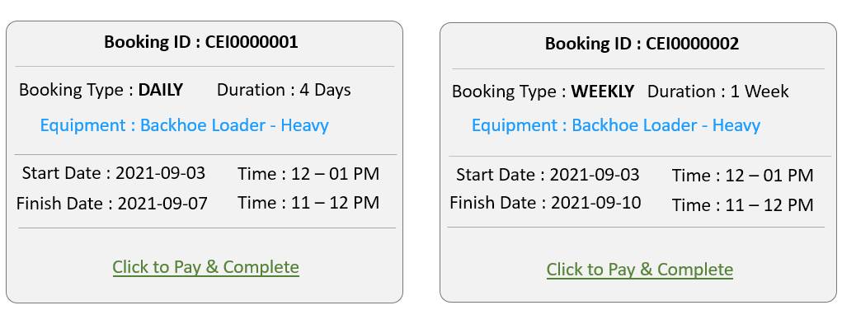

# Checkout Page Payment Fields

**Hourly Example**



**Daily Example**



**Weekly Example**



1. **Acknowledgement Page Payment Details.**

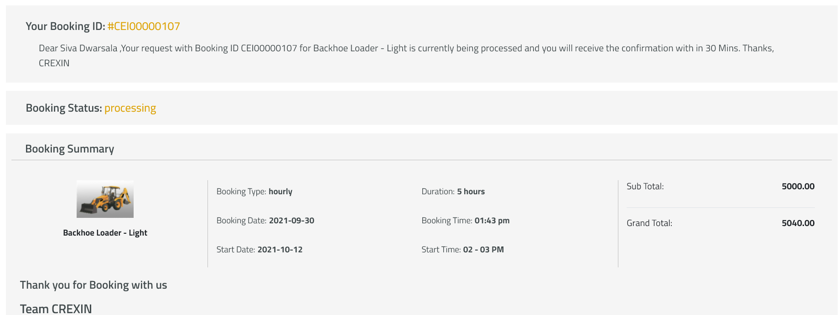

Instead of above two Fields show as below

***Hourly & Daily***

Grand Total 5040.00

Advance Paid 5040.00

Total Due Amount 0.00

**Weekly**

Grand Total 5040.00

Advance Paid 500.00

Total Due Amount 4000.00

End of Week1 1000.00

End of Week2 1000.00 *Based on Booking Duration*

End of Week3 1000.00

End of Week4 1000.00

1. **Booking Details**

**Either we should show labels names for all fields or Keep only Values for Site Address & Billing address details. We don’t n**

